Chapter 14, Problem 18.

A linear network has this transfer function

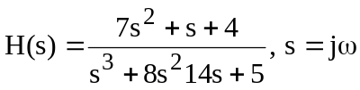

Use MATLAB or equivalent to plot the magnitude and phase (in degrees) of the transfer function. Take 0.1 < ω < 10 rad/s.

